Matlab to Robotarm Interface User Manual
V1.0
CTB536-10-0191 2010-03-23

Matlab to Robotarm Interface User Manual
V1.0
Mechatronics
R.A. Beekmans
CTB536-10-0191 2010-03-23

Published by: Philips Electronics Nederland B.V.
Philips Applied Technologies
Eindhoven, The Netherlands

Title: Matlab to Robotarm Interface User Manual, V1.0
Author: R.A. Beekmans
Document code: CTB536-10-0191
Date: 2010-03-23
Distribution:
Status: Released

If you have any comment to make, please feel free to contact the author:
Philips Applied Technologies
Mechatronics
R.A. Beekmans
High Tech Campus 7
Eindhoven, the Netherlands
Tel.: +31 40 27 48502

Copies of this document can be ordered from the distributor:
Philips Applied Technologies
Mechatronics
Secretary
High Tech Campus 7
Eindhoven, the Netherlands
Tel.: +31 40 27 48793
© Koninklijke Philips Electronics N.V. 2010
All rights reserved. Reproduction in whole or in part is prohibited without the written consent of the copyright owner.

Contents
1 Introduction 5
1.1 Document History 5
1.2 Document Links 5
2 System configuration 6
2.1 Required Files 6
3 Using from Matlab 8
3.1 Matlab versions 8
3.2 ServoManager interface 8
3.2.1 Creating the active-X server 8
3.2.2 ConnectToTarget 8
3.2.3 ControllerCount 9
3.2.4 GetController( servoIndex ) 9
3.2.5 ReloadParameters 9
3.2.6 StartTrace( traceDuration ) 9
3.2.7 StopTrace 10
3.2.8 SaveTrace( fileName ) 10
3.2.9 StartSequence( fileName ) 10
3.2.10 StopSequence 10
3.3 ServoController interface 11
3.3.1 Controller states 11
3.3.2 CloseLoop 12
3.3.3 OpenLoop 12
3.3.4 HomeController 12
3.3.5 ResetError 12
3.3.6 Stop 12
3.3.7 ResetMaxPositionError 13
3.3.8 Name 13
3.3.9 StartPTP( newPosition ) 13
3.3.10 ControllerState 13
3.3.11 GetIOStatus 14
3.3.12 SetPTPSetpointParams( maxVel, maxAcc) 14
3.3.13 GetPTPSetpointParams 14
4 Interface files 15
4.1 COM IDL File 15
5 Examples 17
5.1 Servo initialize, move, shutdown 17

Introduction
This document describes the user functions of the Matlab to Robotarm interface. The MatlabToRobotarmIF can be used to control the Apptech Robotarm.

The following chapter describes a system overview of the MatlabToRobotarmIF components and their relationships. Chapter 3 describes how the MatlabToRobotarmIF functions can be called from Matlab. In the last chapter, examples are shown of using the MatlabToRobotarmIF.

Document History
Date | Version/Status | Notes
2010-03-22 | V0.9 / Draft | Initial version
2010-03-23 | 1.0 / Released | Small updates

Document Links
[1] User Instruction Manual, Philips Experimental Robot Arm, R. Rijs e.a, Apptech document number: APT536-09-9962.

System configuration
The MatlabToRobotarmIF can be used to control the servos in the Apptech Robotarm.

The MatlabToRobotarmIF.exe is a COM server that performs the data translation between Matlab and the Robotarm controller. On the user side it exposes a COM interface and it can connect to a CORBA interface on the target.

User Application (e.g. Matlab): A user application that can call functions on a Microsoft COM interface and can be used to controls the servos.

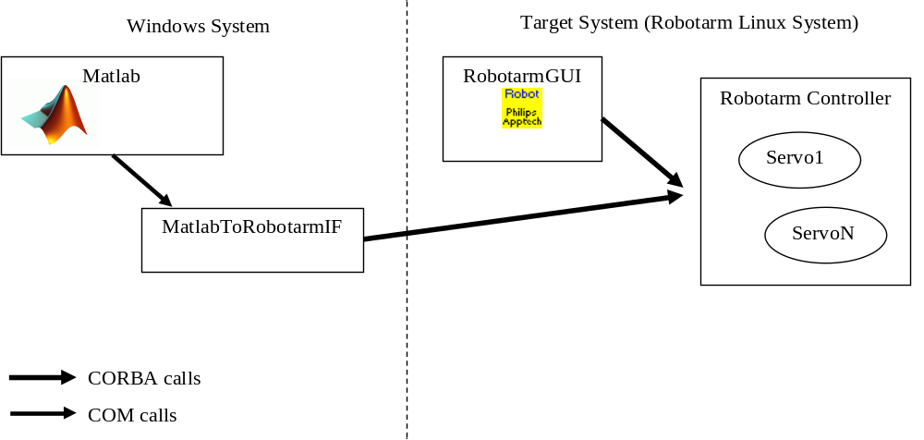Figure 1: Component relations

Required Files
To use the MatlabToRobotarmIF the files listed below have to be installed on the system controller. These files can be found in the Apptech Robotics SharePoint in the folder: Shared Documents/Robotarm_v2/Philips Apptech/Software/ MatlabToRobotarmIF / MatlabToRobotarmIF distribution.zip.

Required files:
- MatlabToRobotarmIF.exe
- ACE.dll
- TAO.dll
- TAO_AnyTypeCode.dll
- TAO_IORTable.dll
- TAO_PortableServer.dll

The MatlabToRobotarmIF.exe has to be registered before it can be used.

This is done with the following commands:

Open a Command Prompt (click on the Start menu, then Run… and enter cmd and click on OK. This will open a Command Prompt window.

- cd <directory with MatlabToRobotarmIF files>
- MatlabToRobotarmIF.exe /RegServer
- Exit

Using from Matlab
With the MatlabToRobotarmIF it is possible to control servos of the Apptech Robotarm. To give access, two COM interfaces are defined; the ServoManager and the ServoController.

This chapter describes how to start MatlabToRobotarmIF from Matlab and how to connect to the target; The COM interfaces will be described in the sections below.

Matlab versions
The MatlabToRobotarmIF has been tested with Matlab 2007a (7.4). Between the Matlab versions there are some syntax differences. For most methods the syntax is the same; however calls that return multiple values use a different syntax. Examples of the two syntax forms are shown below:

Matlab 6.5.1 syntax
>> [name, idx] = invoke(target, ‘TraceConnectGet’, 0);

Matlab 7.1 / 2007a syntax
>> [name, idx] = target.TraceConnectGet(0);

ServoManager interface
The ServoManager component is the only component that can be created directly from Matlab. When a connection to the target is made; the pointers to the ServoControllers can be obtained via the ServoManager

Creating the active-X server
To create the active-x server in Matlab, use the actxserver function with the name of the MatlabToRobotarmIF class as parameter. The command is shown below. This function only creates the active-x server on the system controller system, it does not connect to a target.

>> manager = actxserver(‘MatlabToRobotarmIF.ServoManager’)

ConnectToTarget( connectString )
Before the active-x server can be used, a connection to the target has to be made. This is done with the ConnectToTarget call. The exact connect string is defined by the software in the target system.

Name: ConnectToTarget
Arguments: (string) connectString - CORBA initialization string, i.e. location of IORtable or object location.
Returns: -

This call creates the connection to the target system.
>> manager.ConnectToTarget(‘-RemoteORBEndpoint 192.168.1.2:7012’)

ControllerCount
This method returns the number of ServoControllerNames that are available on the target.

Name: ControllerCount
Arguments: -
Returns: (int) # ServoControllers

>> count = manager.ControllerCount

GetController( servoIndex )
This method returns the ServoController interface for the controller with the requested index.

Name: GetController
Arguments: (int) servoIndex.
Returns: (IServoController) servoControllerInterface

If a parameter name is not valid, an exception is thrown

>> controller = manager.GetController( 0 )

ReloadParameters
This method re-loads all servocontrollers with the values in the file servoParams.ini

Name: ReloadParameters
Arguments: -
Returns: (int) rv – return value, 0 = successful, otherwise indicates and error

>> manager.ReloadParameters

StartTrace( traceDuration )
This method starts a trace with the specified duration. The tracedata is kept in memory until it is saved with the SaveTrace method. The traceDuration is specified in samples, the current robotarm is running 500 samples per second so a traceduration of 10000 corresponds to a 20 second trace.

Name: StartTrace
Arguments: (int) traceDuration.
Returns: (int) rv – return value, 0 = successful, otherwise indicates and error

>> manager.StartTrace( 10000 )

StopTrace
This method stops a trace.

Name: StopTrace
Arguments: -
Returns: (int) rv – return value, 0 = successful, otherwise indicates and error

>> manager.StopTrace

SaveTrace( fileName )
This method saves the trace data that is kept in memory to a file. The file is formatted as a csv file. The first line of the file indicates the layout of the file.

Name: SaveTrace
Arguments: (string) fileName
Returns: (int) rv – return value, 0 = successful, otherwise indicates and error

>> manager.SaveTrace(‘TraceData.csv’)

StartSequence( fileName )
This method starts the execution of a command sequence. The formatting of the sequence files is described in section 2.4.3 of [1].

Name: StartSequence
Arguments: (string) fileName
Returns: (int) rv – return value, 0 = successful, otherwise indicates and error

>> manager.StartSequence(‘MoveDemo.txt’)

StopSequence
This method stops a running sequence

Name: StopSequence
Arguments: -
Returns: (int) rv – return value, 0 = successful, otherwise indicates and error

>> manager.StopSequence

ServoController interface
Through the ServoController interface the corresponding servo can be controlled from Matlab. The following section describes the state behaviour of the servos of the Apptech Robotarm; the following sections describe each method of the ServoController interface briefly.

Controller states
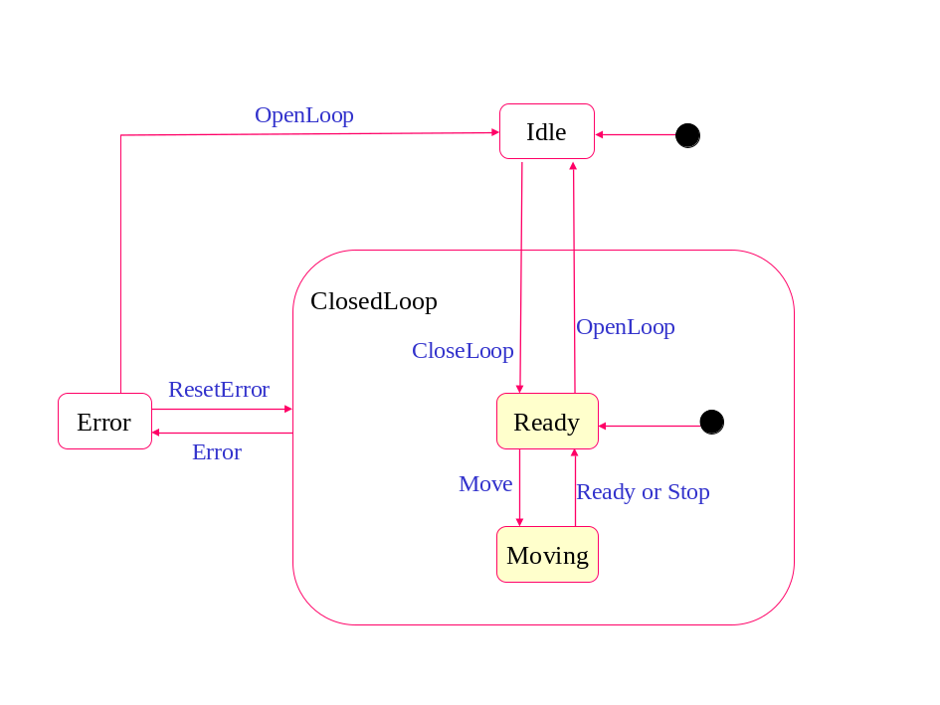
Figure 2: Controller States

The state transition events in the diagram can be user events (commands) or internal servo events. The events are described briefly below, the user events are marked with a U and the internal servo events with a I.

CloseLoop U Performs servo initialisation, enables the amplifiers and closes the control loop.
OpenLoop U Opens the control loop and switches off the amplifiers.
StartPTP U Starts a movement (PTP).
Stop U Stop movement user current.
ResetError U Resets the error and goes to the ClosedLoop.
Ready I Indicates that the movement has stopped.
Error I Raised when an error in the servo occurred.
TrackingError I Raised when the tracking error becomes larger than the limits for the selected controllerset.

CloseLoop
Initializes the servo, i.e. Resets the setpoint generatorm, resets the integrator, enables the amplifiers and closes the servo loop.

Name: CloseLoop
Arguments: -
Returns: (int) rv – return value, 0 = successful, otherwise indicates and error

>> rv = controller.CloseLoop

OpenLoop
This method opens the control loop and disables the amplifier.

Name: OpenLoop
Arguments: -
Returns: (int) rv – return value, 0 = successful, otherwise indicates and error

>> controller.OpenLoop

HomeController
This method sets the current position to 0 (zero). This call can be used both open loop and closed loop.

Name: HomeController
Arguments: -
Returns: (int) rv – return value, 0 = successful, otherwise indicates and error

>> controller.HomeController

ResetError
This method resets the controller error and makes the controller closed loop again.

Name: ResetError
Arguments: -
Returns: (int) rv – return value, 0 = successful, otherwise indicates and error

>> controller.ResetError

Stop
This method stops a move.

Name: Stop
Arguments: -
Returns: (int) rv – return value, 0 = successful, otherwise indicates and error

>> controller.Stop;

ResetMaxPositionError
This method resets the maximum tracking error value that is kept when the servo is closed loop.

Name: ResetMaxPositionError
Arguments: -
Returns: (int) rv – return value, 0 = successful, otherwise indicates and error

>> controller.ResetMaxPositionError

Name
Returns the name of the servo

Name: Name
Arguments: -
Returns: (string) name of the servo controller

>> servoName = controller.Name;

StartPTP( newPosition )
Starts a Point-To-Point move to the newposition. The move positions are all specified in degrees.

Name: StartPTP
Arguments: double newPosition – end position of the move [deg]
Returns: (int) rv – return value, 0 = successful, otherwise indicates and error

>> controller.StartPTP( 1.0 );

ControllerState
Returns the current controller status. This call returns multiple values that were all used during the last sample calculation.

Name: ControllerState
Arguments: -
Returns: (EControllerState) state, the current controller state
(double) actualPos, current actual position of the servo [deg]
(double) setpointPos, current setpoint position of the servo [deg]
(double) maxTrackingErr, the maximum tracking error that has occurred since ClosedLoop or ResetmaxTrackingError calls.

>> [state, actPos, setPos, maxErr] controller.ControllerState;

GetIOStatus
Returns the status of the two analog inputs of the servo.

Name: GetIOStatus
Arguments: -
Returns: (double) absPos, the value of the magnetic absolute position sensor
(double) motorForce, the value of the force sensor in the joint.

>> [absPos, motorForce] = controller.GetIOStatus;

SetPTPSetpointParams( maxVel, maxAcc)
This method sets the maximum velocity and maximum acceleration parameters for the Point-To-Point setpoint generator in the servo.
Note: both values should be positive.

Name: SetPTPSetpointParams
Arguments: (double) maxVel [deg/s],
(double) maxAcc [deg/s^2]
Returns: (int) rv – return value, 0 = successful, otherwise indicates and error

>> controller.SetPTPSetpointParams(1.0, 5.0);

GetPTPSetpointParams
This method returns the maximum velocity and maximum acceleration parameters of the setpoint generator.

Name: GetPTPSetpointParams
Arguments: -
Returns: (double) maxVel, maximum velocity [deg/s]
(double) maxAcc, maximumAccelation [deg/s^2]

>> [maxVel, maxAcc] = controller.GetPTPSetpointParams;

Interface files
The section below shows the IDL files for the COM interface of the MatlabToRobotarmIF.

COM IDL File
typedef enum EControllerState
{
OPENLOOP_STATE = 0,
READY_STATE = 1,
MOVING_STATE = 2,
ERROR_STATE = 3,
} EControllerState;

[
object,
uuid(89405B1E-49EC-43DD-BA8A-F100F9F9D3D3),
dual,
helpstring("IServoController Interface"),
pointer_default(unique)
]
interface IServoController : IDispatch
{
[id(1)] HRESULT CloseLoop([out,retval] LONG *rv);
[id(2)] HRESULT OpenLoop([out,retval] LONG *rv);
[id(3)] HRESULT HomeController([out,retval] LONG *rv);
[id(4)] HRESULT ResetError([out,retval] LONG *rv);
[id(5)] HRESULT Stop([out,retval] LONG *rv);
[id(6)] HRESULT ResetMaxPositionError([out,retval] LONG *rv);
[propget,id(7)] HRESULT Name([out,retval] BSTR *pVal);
[id(8)] HRESULT StartPTP([in] DOUBLE newPosition,
[out,retval] LONG *rv);
[id(9)] HRESULT ControllerState([out] enum EControllerState *state,
[out] DOUBLE *actualPos,
[out] DOUBLE *setpointPos,
[out] DOUBLE *maxTrackingErr);
[id(10)] HRESULT GetIOStatus([out] DOUBLE *absPos,
[out] DOUBLE *motorForce);
[id(11)] HRESULT SetPTPSetpointParams([in] DOUBLE maxVel,
[in] DOUBLE maxAcc);
[id(12)] HRESULT GetPTPSetpointParams([out] DOUBLE *maxVel,
[out] DOUBLE *maxAcc);

[hidden] HRESULT GetGUID([out] GUID *pGUID);
[hidden] HRESULT GetSource([out] BSTR *pBstrSource);
[hidden] HRESULT GetDescription([out] BSTR *pBstrDescription);
[hidden] HRESULT GetHelpFile([out] BSTR *pBstrHelpFile);
[hidden] HRESULT GetHelpContext([out] DWORD *pdwHelpContext);
};

[
object,
uuid(4D184DA5-1F54-4C15-A9BD-C237EDDB2DE0),
dual,
helpstring("IServoManager Interface"),
pointer_default(unique)
]
interface IServoManager : IDispatch
{
[id(1)] HRESULT ConnectToTarget([in] BSTR target);
[propget,id(2)] HRESULT ControllerCount([out,retval] LONG *pVal);
[id(3)] HRESULT GetController([in] LONG controllerIdx,
[out,retval] IServoController **servo);
[id(4)] HRESULT ReloadParameters([out,retval] LONG *rv);
[id(5)] HRESULT StartTrace([in] LONG traceDuration,
[out,retval] LONG *rv);
[id(6)] HRESULT StopTrace([out,retval] LONG *rv);
[id(7)] HRESULT SaveTrace([in] BSTR fileName, [out,retval] LONG *rv);
[id(8)] HRESULT StartSequence([in] BSTR fileName,
[out,retval] LONG *rv);
[id(9)] HRESULT StopSequence([out,retval] LONG *rv);

[hidden] HRESULT GetGUID([out] GUID *pGUID);
[hidden] HRESULT GetSource([out] BSTR *pBstrSource);
[hidden] HRESULT GetDescription([out] BSTR *pBstrDescription);
[hidden] HRESULT GetHelpFile([out] BSTR *pBstrHelpFile);
[hidden] HRESULT GetHelpContext([out] DWORD *pdwHelpContext);
};

[ version(1.0), uuid(F4470C91-AED2-4D84-95B0-C91D2D1C5FFE), helpstring("MatlabToRobotarmIF 1.0 Type Library") ]
library MatlabToRobotarmIF
{
importlib("stdole2.tlb");
importlib("olepro32.dll");

[
version(1.0),
uuid(903C5E1E-90F9-47F6-AC7A-C86E3A09B2D5),
helpstring("ServoController Class")
]
coclass CServoController
{
[default] interface IServoController;
};

[
version(1.0),
uuid(E6B72EC8-7357-42C5-83BA-74D09F2C0BC8),
helpstring("ServoManager Class")
]
coclass CServoManager
{
[default] interface IServoManager;
};
}

Examples

Servo initialize, move, shutdown
Below an example of initializing, homing and moving a single axis of the Robotarm.

>> manager = actxserver('MatlabToRobotarmIF.ServoManager')
manager =
COM.MatlabToRobotarmIF_ServoManager

>> manager.ConnectToTarget('-RemoteORBEndpoint 130.145.242.78:7012')
>> manager.ControllerCount
ans =
8

>> Servo1 = manager.GetController( 1 )
Servo1 =
Interface.MatlabToRobotarmIF_1.0_Type_Library.IServoController

>> Servo1.get
Name: {‘SHL2’}

>> Servo1.CloseLoop
ans =
0

>> Servo1.HomeController
ans =
0

>> [state, actPos, setPos, maxErr] = Servo1.ControllerStatus
state =
‘READY_STATE’
actPos =
0.001
setPos =
0.0
maxErr =
0.002

>> [v, a] = Servo1.GetPTPSetpointParams
v =
5 5
a =
50 50

>> Servo1.StartPTP( 10.0 )
ans =
0

>> [state, actPos, setPos, maxErr] = Servo1.ControllerStatus
state =
‘MOVING_STATE’
actPos =
2.001
setPos =
0.0
maxErr =
0.05

>> Servo1.OpenLoop
ans =
0

>> Servo1.release

>> manager.release

--o--o--o--

